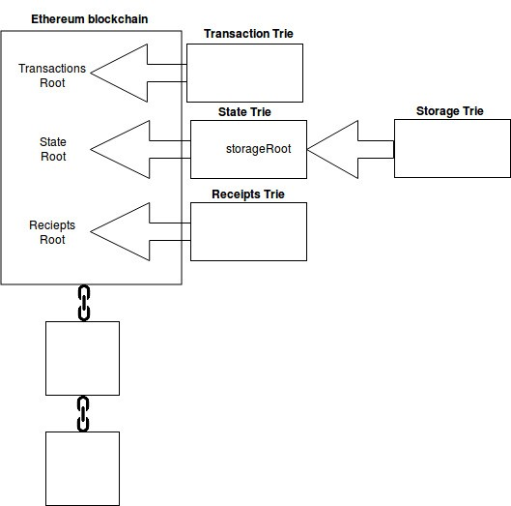
Importantly, data such as account balances are not stored directly in the blocks of the Ethereum blockchain. Only the root node hashes of the transaction trie, state trie and receipts trie are stored directly in the blockchain. This is illustrated in the diagram below.
In Ethereum, every account has a public viewable nonce and every time a transaction is made, the nonce is increased by one. This can prevent the same transaction being submitted more than once. (Note, this nonce is different from the Ethereum proof of work nonce, which is a random value.)

There is one, and one only, global state trie in Ethereum.
This global state trie is constantly updated.
The state trie contains a key and value pair for every account which exists on the Ethereum network.
The main Ethereum clients use two different database software solutions to store their tries. Ethereum’s Rust client Parity uses rocksdb. Whereas Ethereum’s Go, C++ and Python clients all use leveldb.

admin.nodeInfo.enode
net.listening
net.peerCount
admin.peers
eth.coinbase
eth.getBalance(eth.coinbase)
personal
eth.accounts
miner.setEtherbase(web3.eth.accounts[0])
miner.setEtherbase(“0xae13d41d66af28380c7af6d825ab557eb271ffff”)
miner.start()
miner.stop()
miner.hashrate
eth.getBlock(0)
eth.getBlock(“latest”)
eth.blockNumber
web3.eth.getBlock(BLOCK_NUMBER).hash
eth.syncing
debug.verbosity(6) // highest logging level, 3 is default

